Images of Enslavement and the Slave Trade
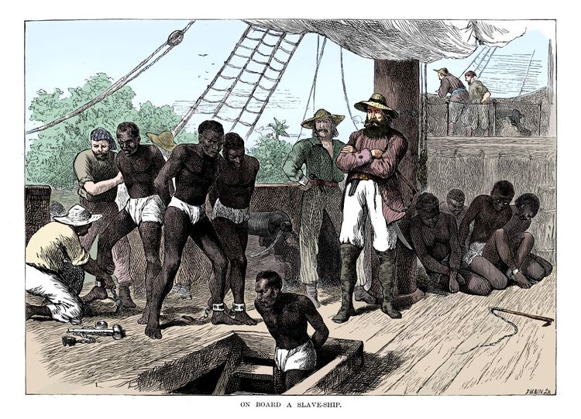
Although Britain outlawed slavery in 1833 and it was abolished in the U.S. after the defeat of the Confederacy in the Civil War in 1865, the trans-Atlantic trade in enslaved African people continued. The main market for enslaved people was Brazil, where enslavement was not abolished until 1888.

Key Takeaways
- Enslaved African people faced inhumane conditions and cruel treatment on the Middle Passage to the Americas.
- Various forms of enslavement, like pawnship, kept people in bondage both locally and across oceans.
- Barracoons held captives for months before they were sold to European enslavers and taken across the ocean.
These images depict scenes from the trans-Atlantic slave trade. They illustrate the capture, confinement, and inhumane conditions experienced by enslaved African people as they were kidnapped by slave traders and forcibly transported to the Americas on the Middle Passage.

Pawnship
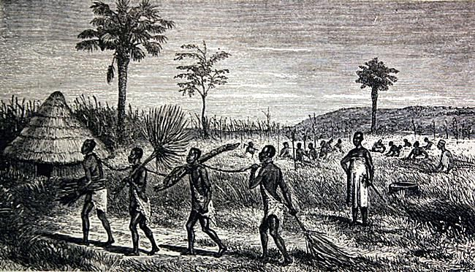
Journey of the Discovery of the Source of the Nile" by John Hanning Speke, New York 1869
The enslavement of Indigenous people in West Africa was known as pawnship. The practice of pawnship was a type of debt bondage in which an individual paid off a debt either through their own or a relative's labor.
Unlike the trans-Atlantic slave trade, which kidnapped and enslaved African people far from their homes and culture, those enslaved under pawnship remained in their own community. However, they were still restrained from escape.
"A Slaver's Canoe" 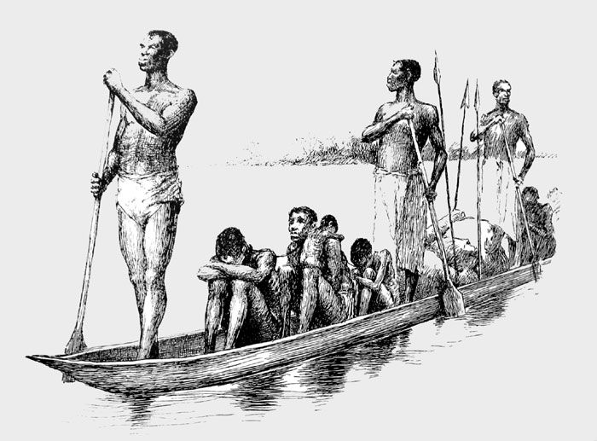
Boy Travelers on the Congo" by Thomas W Knox, New York 1871
Captives were transported considerable distances down river (seen here, the Congo) by slave traders to be enslaved by Europeans.

Indigenous Slave Traders Traveling From the Interior

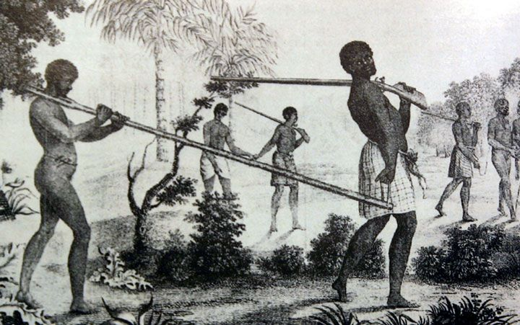
"Voyage à la Côte Occidentale d'Afrique" by Louis Degrandpré, Paris 1801
Indigenous African slave traders from coastal regions would travel far into the interior to capture and enslave African people. They were generally well armed, having obtained guns from European merchants. As seen in this image, captives were yoked with a forked branch and fixed in place with an iron pin across the back of their necks. The slightest tug on the branch could choke the captive.

